

Book of the Month

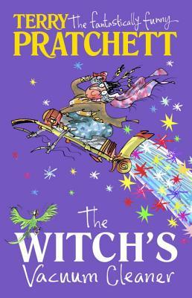
Was €9.60

ENNIS NATIONAL SCHOOL SPECIAL PRICE €7.65

The Witch’s Vacuum Cleaner by Terry Pratchett

Do you believe in magic?

Can you imagine a war between wizards, a submarine the size of a walnut or a time-travelling television? Can you image that poor old Mr. Swimble could see a mysterious vacuum cleaner in the morning and make cheese sandwiches and yellow elephants magically appear by the afternoon?

Welcome to the wonderful world of Sir Terry Pratchett and fourteen fantastically funny tales from the master storyteller. Bursting from the pages are food fights, pirates, bouncing rabbits and magical pigeons. And a witch riding a vacuum cleaner, of course.

The Ennis Bookshop invites Ennis National School students to avail of a 20% DISCOUNT on our Book of the Month when you present this flyer in The Ennis Bookshop.

